 **12 Dec 2014** **The Weekly Bulletin of Rotary Club of Kathmandu Mid-Town** **bc-23/12.014**

|  |
| --- |
|  |

District: 3292 Web:www.rotarymidtown.org.np Club Id: 26776

**DECEMBER IS THE FAMILY MONTH**

**Encourage clubs to have Rotary activities and projects that involve Rotarians’ families.**

**Rotary should make time for families – not take time from families!**

Extracts of Club’s Regular Weekly Meeting # 1257 held on Friday, 5 December:

“1. Meeting No.1257 was called to order at 8:00 AM

“7. Short talk about Polygraph Tests in Nepal. Rtn Larry Kelly introduced guests Dipak Bhandari and Deputy Sub

Inspector Jyoti Thapa of the Nepal Police Polygraph Unit. Mr Bandhari gave a fascinating account of the short history

of polygraph in Neal as well as several amazing examples of how tis tool has helped to solve some baffling crimes.

Rtn Rabindra gave the vote of thanks.

“8. Presentation of annual contribution check to Rtr Pres Sujan Manandhar. This is Mid-Town's annual contribution to its

Rotaracts and 3 Interact Clubs. Pres Kulchandra wished them well in the upcoming year's work. He also congratulated

Rtr Pres Sujan who would soon be taking up DFID-supported civil engineering work in Humla. Mid-Town gave a warm

round of applause.

“9. Information sharing:

> Pres Kulchandra reminded everyone about the upcoming Mid-Town trip to Mugu, (Dec. 12-16) Please make sure that

we get some good photos and please help us to collect a few really good 'success stories'

> If you have photos from past meetings please share with Sec Isa (for the DG's visit report) and with PP Lekha for the

Governor's Monthly Newsletter (a great job is being done this year by editor PP Lekha!)

> Remember to please submit nominations for the Gopal and Kamala Rajbandari Educational Awards by Dec 15th

2014. The form was circulated by email.

> Anyone still needing to clear the bill for guests and friends who attended the Charter Day dinner please remit to Mr

Dahal at your earliest convenience.

> A CD of all photos taken by a professional photographer on the occasion of our 25th Charter Day Celebration is on

sale now (for 300 Nrs). See Mr Dahal.

> The Kathmandu Chorale will present their annual concert of Christmas music – next Saturday at the British School

(two performances 3:30 PM and 6 PM) – fun for the whole family. Admission: free

> The AWON Christmas Bazaar – Saturday Dec 6 – on the grounds of the Hyatt Hotel (10AM-4PM) – fun for the whole

family. Admission: 100 Nrs for adults, 50 Nrs for children.

> Bom dia! You’re invited to the 2015 Rotary International Convention in São Paulo, Brazil. The fun begins on

Saturday, 6 June and continues through Tuesday, 9 June 2015. Who will attend from Mid-Town?

> This year's Gift of Sight will take place in Hetauda on 30 Jan 2015.

> Anyone wishing to join the 'Saturday morning walking group' please contact PP Komal.

“10. Statistics of the meeting: Members present: 25”.

# Weekly Meetings and Programs :

|  |  |  |
| --- | --- | --- |
| Date | Program/Speaker | Topic of Presentation |
| 12 December | Dr Milan, ENT Specialist | ?? |
|  |  |  |
|  |  |  |
|  |  |  |

**RI Convention : Sao Paulo**

**Registration fees**

Deadline 1: 15 Dec 014 Deadline 2: 31 Mar 015 After 31 March

Convention registration

Rotarian, spouse, guest or RC employee $ 325 $ 375 $ 425

Rotaractor or guest $ 70 $ 100 $ 130

Interactor, guest age 5-18 $ 10 $ 10 $ 10

*Source: Rotary International*

**Committee Chairs’ Column:** *(This column is for use by chairpersons of 5 permanent committees: Club Administration, Membership, Public Relations, Service Projects, and the Rotary Foundation)*

( ? )

**Gopal-Kamala Rajbhandary**

**Rotary Vocational Excellency Award**

A request from PDG Tirtha Man Sakya, Chair, GKR Rotary Vocational Excellency

Award recommendation committee:

“Please make sure the nomination form for GKR Rotary Vocational Excellency Award from your club reaches the Rotary District Office, Thapathali, within 15 December 2014.”

**The Rotary Foundation Seminar**

The District Rotary Foundation Seminar is going to be held on 27 December 2014.

ARRFC Deepak Talwar will be the keynote speaker on that day.

Information on the venue, timing and registration fee will follow.

Please contact PDG Basu Dev Golyan, Chair, District Rotary Foundation Committee, or

at the Rotary District Office (email: [rotary@ntc.net.np](mailto:rotary@ntc.net.np)  Tel: 016224166/98373897)

**Polio Plus: Pakistan**

Following increasing attacks and shooting of polio and other health workers administering polio vaccine to children in Pakistan’s tribal areas, the Rotary Pakistan Polio Ulema Committee Chair Haji Hanif Tayyab and National Chair Polio Plus Committee Aziz Memon organised a workshop for Ulemas to discuss this issue.

The workshop, which condemned the killing of polio health workers and called upon the government to address the “grievances” of segments opposing vaccination, was attended by leading Ulema, religious leaders and scholars of the city.

Read more at <http://www.thenews.com.pk/Todays-News-4-287624-Ulema-workshop-denounces-killing-of-polio-workers>.

*Source: Internet News*

**International Civil Aviation Day: 7 December**

International Civil Aviation Day was established in 1994 by ICAO, through Assembly Resolution A29-1, to mark the 50th anniversary of the Organization, created on 7 December 1944. In 1996, pursuant to an ICAO initiative and with the assistance of the Canadian Government, the United Nations General Assembly by resolution officially recognized 7 December as International Civil Aviation Day and listed it as an official UN day. The purpose of the global celebration is to generate and reinforce worldwide awareness of the importance of international civil aviation in the social and economic development of States, and of the role of ICAO in promoting the safety, efficiency and regularity of international air transport.

*Source: Internet*

**International Anti-Corruption Day**

**(9 December)**

2014 Theme: **Break the corruption chain**



“On this International Anti-Corruption Day, I urge Governments, the private

sector and civil society to take a collective stand against this complex

social, political and economic disease that affects all countries.

To achieve an equitable, inclusive and more prosperous future for all,

we must foster a culture of integrity, transparency, accountability and

good governance.” *- UN Secretary General Ban Ki-moon*

Corruption is a complex social, political and economic phenomenon that affects all countries. Corruption undermines democratic institutions, slows economic development and contributes to governmental instability. Corruption attacks the foundation of democratic institutions by distorting electoral processes, perverting the rule of law and creating bureaucratic quagmires whose only reason for existing is the soliciting of bribes. Economic development is stunted because foreign direct investment is discouraged and small businesses within the country often find it impossible to overcome the "start-up costs" required because of corruption.

On 31 October 2003, the General Assembly adopted the United Nations Convention against Corruption and designated 9 December as International Anti-Corruption Day, to raise awareness of corruption and of the role of the Convention in combating and preventing it.  The Convention entered into force in December 2005.

*Source: Internet*

**Human Rights Day**

**(10 December)**

**2014 Theme:** **Human Rights 365**



"I call on States to honour their obligation to protect human rights

every day of the year. I call on people to hold their governments

to account." *- UN Secretary General Ban Ki-moon*

The UN General Assembly proclaimed 10 December as Human

Rights Day in 1950, to bring to the attention ‘of the peoples of

the world’ the Universal Declaration of Human Rights as the common standard of achievement for all peoples and all nations.

This year’s slogan, **Human Rights 365**, encompasses the idea that every day is Human Rights Day. It celebrates the fundamental proposition in the Universal Declaration that each one of us, everywhere, at all times is entitled to the full range of human rights, that human rights belong equally to each of us and bind us together as a global community with the same ideals and values.

**What are human rights?**

Human rights are rights inherent to all human beings, whatever our nationality, place of residence, sex, national or ethnic origin, colour, religion, language, or any other status. We are all equally entitled to our human rights without discrimination. These rights are all interrelated, interdependent and indivisible. ….. (*More on Annex ‘A’*)

*Source: Internet*

**Members’ Corner:** *(This column is for Club members to express anything they would like in matter of Club activities, Club administration, Club issues or on Breakfast Chatter, or on anything else that would be of interest to fellow members.)*

( ? )

Travel and Tourism



.*Source: Internet*

On Lighter Side :

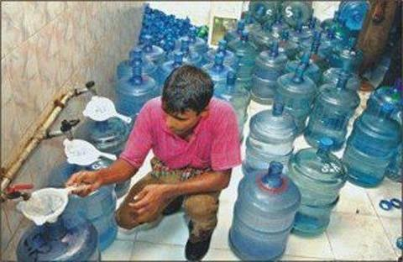

Filtering water for refilling jars!



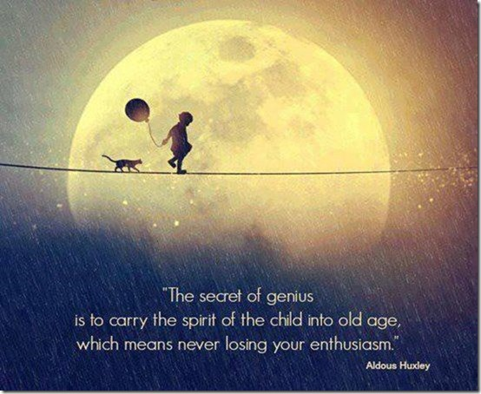

*Courtesy: Rtn Isabella Khadka*

**A THOUGHT FOR TODAY:**

**The real index of civilization is**

**when people are kinder than they need to be.**

Louis de Bernieres, novelist (b. 1954)

*Courtesy: Rtn Isabella Khadka*

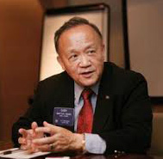

Bringing your family into Rotary doesn't just Light Up Rotary – it lights up your own lives as

well.

**RI President GARY C.K. HUANG**

Please send information on club activities, progress reviews on service projects, relevant photos etc to:

BC Editor: RR Shrestha email: rryesrr@gmail.com

## 12 December 2014 The Weekly Bulletin of Rotary Club of Kathmandu Mid-Town bc-23/12.014

*******************************

Annex ‘A’

**What are human rights?**

Human rights are rights inherent to all human beings, whatever our nationality, place of residence, sex, national or ethnic origin, colour, religion, language, or any other status. We are all equally entitled to our human rights without discrimination. These rights are all interrelated, interdependent and indivisible.

Universal human rights are often expressed and guaranteed by law, in the forms of treaties, customary international law , general principles and other sources of international law. International human rights law lays down obligations of Governments to act in certain ways or to refrain from certain acts, in order to promote and protect human rights and fundamental freedoms of individuals or groups.

**Universal and inalienable**

The principle of universality of human rights is the cornerstone of international human rights law. This principle, as first emphasized in the Universal Declaration on Human Rights in 1948, has been reiterated in numerous international human rights conventions, declarations, and resolutions. The 1993 Vienna World Conference on Human Rights, for example, noted that it is the duty of States to promote and protect all human rights and fundamental freedoms, regardless of their political, economic and cultural systems.

All States have ratified at least one, and 80% of States have ratified four or more, of the core human rights treaties, reflecting consent of States which creates legal obligations for them and giving concrete expression to universality. Some fundamental human rights norms enjoy universal protection by customary international law across all boundaries and civilizations.

Human rights are inalienable. They should not be taken away, except in specific situations and according to due process. For example, the right to liberty may be restricted if a person is found guilty of a crime by a court of law.

**Interdependent and indivisible.**

All human rights are indivisible, whether they are civil and political rights, such as the right to life, equality before the law and freedom of expression; economic, social and cultural rights, such as the rights to work, social security and education , or collective rights, such as the rights to development and self-determination, are indivisible, interrelated and interdependent. The improvement of one right facilitates advancement of the others. Likewise, the deprivation of one right adversely affects the others.

**Equal and non-discriminatory**

Non-discrimination is a cross-cutting principle in international human rights law. The principle is present in all the major human rights treaties and provides the central theme of some of international human rights conventions such as the International Convention on the Elimination of All Forms of Racial Discrimination and the Convention on the Elimination of All Forms of Discrimination against Women.

The principle applies to everyone in relation to all human rights and freedoms and it prohibits discrimination on the basis of a list of non-exhaustive categories such as sex, race, colour and so on. The principle of non-discrimination is complemented by the principle of equality, as stated in Article 1 of the Universal Declaration of Human Rights: “All human beings are born free and equal in dignity and rights.”

**Both Rights and Obligations**

Human rights entail both rights and obligations. States assume obligations and duties under international law to respect, to protect and to fulfil human rights. The obligation to respect means that States must refrain from interfering with or curtailing the enjoyment of human rights. The obligation to protect requires States to protect individuals and groups against human rights abuses. The obligation to fulfil means that States must take positive action to facilitate the enjoyment of basic human rights. At the individual level, while we are entitled our human rights, we should also respect the human rights of others.